**Do-while script**

**Script to run for a number of times**

#!/bin/bash

C=1

While [ $c -le 5 ]

do

echo “welcome $c times”

(( c++ ))

done

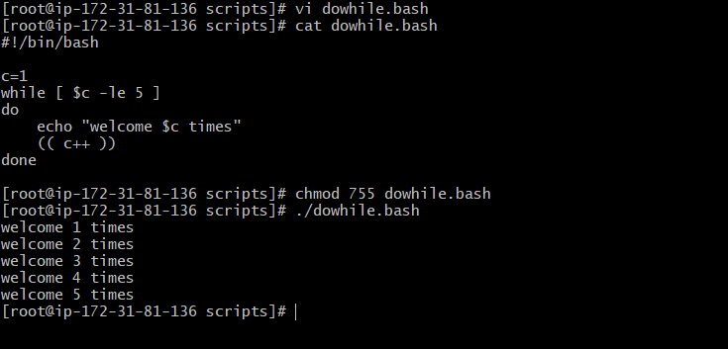

**script to run for a number of seconds**

#!/bin/bash

Count=0

Num=10

While [ $count -it 10 ]

do

echo

echo $num seconds left to stop this process $1

echo

sleep 1

num=’expr $num – 1’

count=’expr $count + 1’

done

echo

echo $1 process is stopped!!!

Echo

